WINDOWS ADMINISTRATION

calc.exe – Opens Windows Calculator

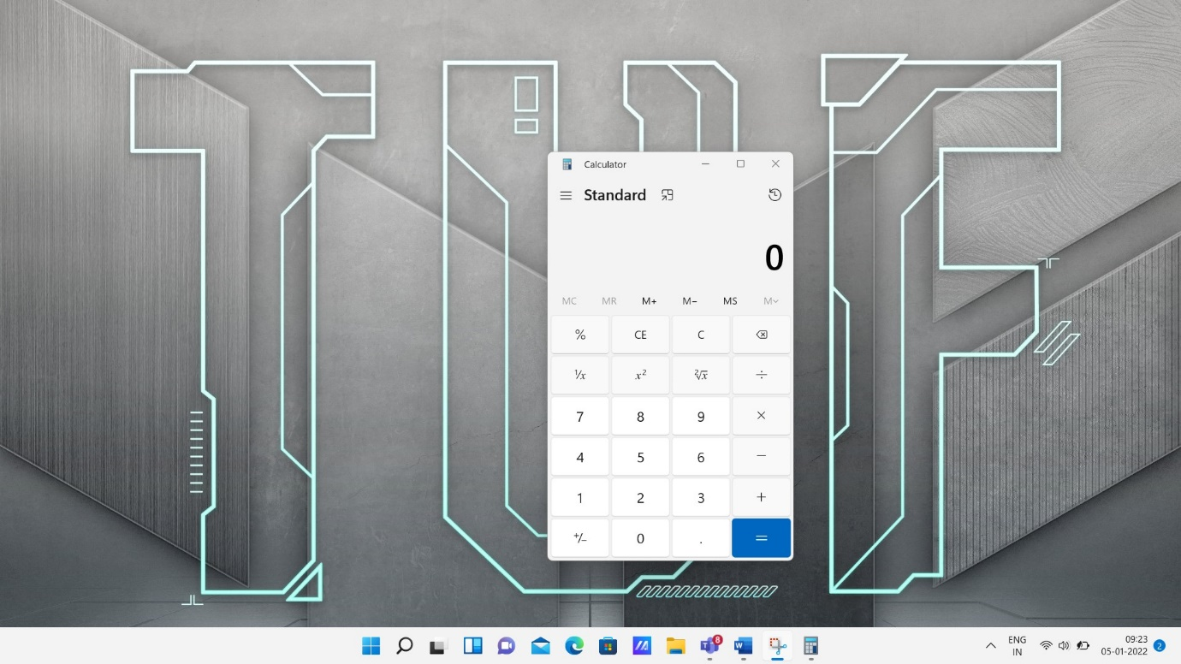

cmd.exe – Opens Command Prompt

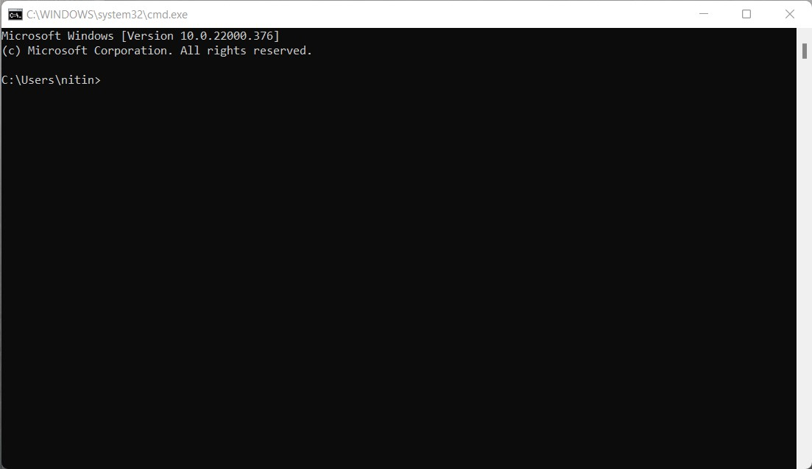

dxdiag.exe – To troubleshoot problems with DirectX sound and video

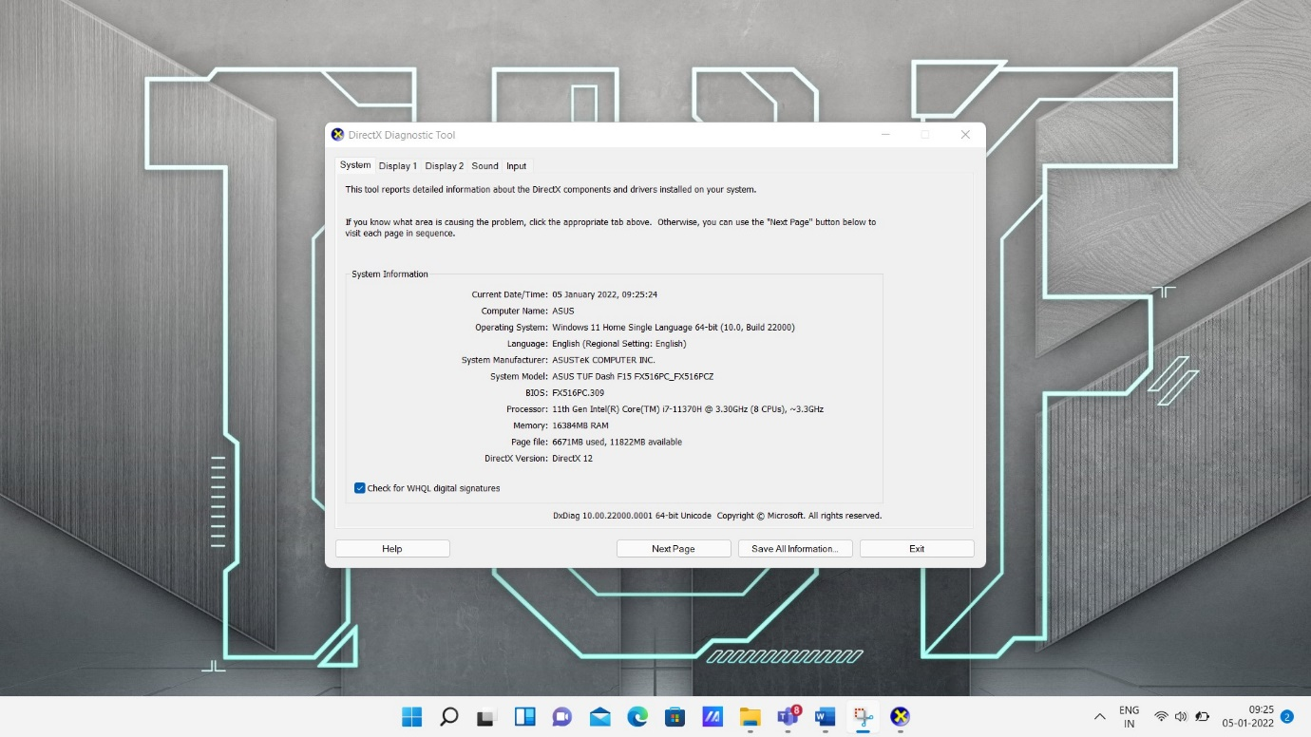

mmc.exe - To create, save and open administrative tools, called consoles

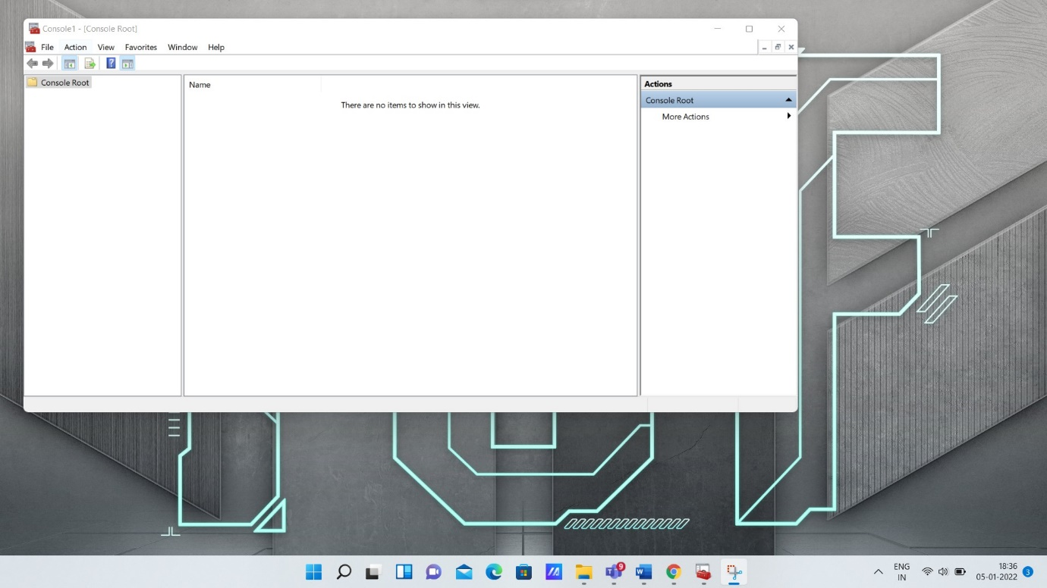

mspaint.exe - To **create picture files** as well as edit picture files 

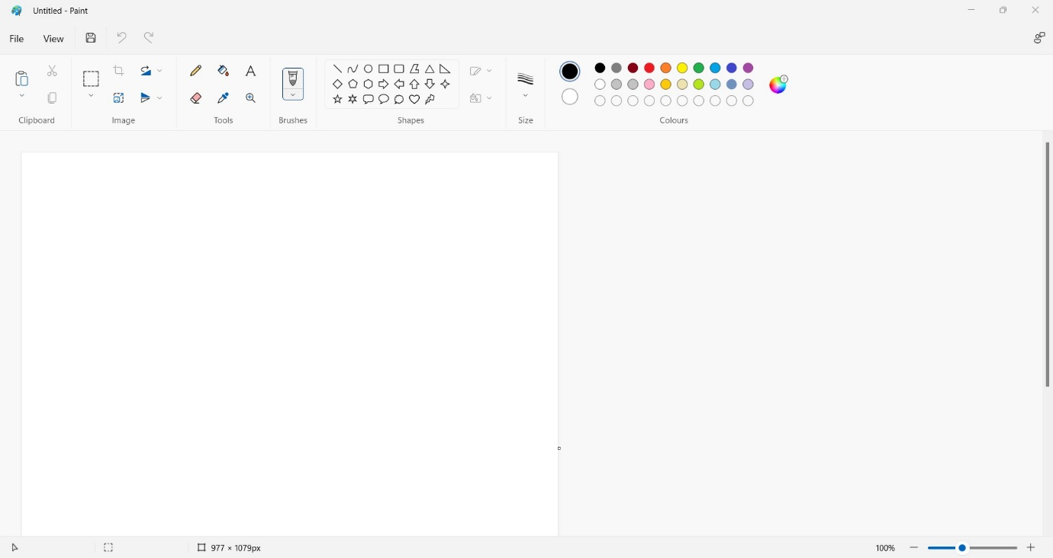

osk.exe – Opens Microsoft's On-Screen Keyboard

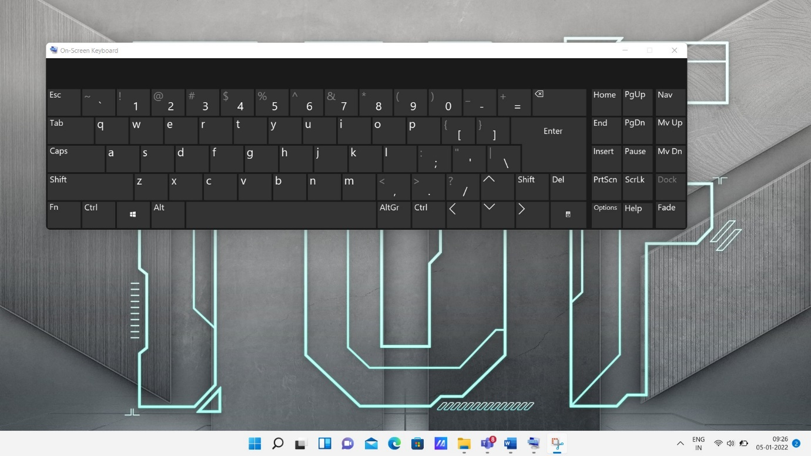

perfmon.exe - Its user interface (GUI) harnesses the underlying ability of Windows

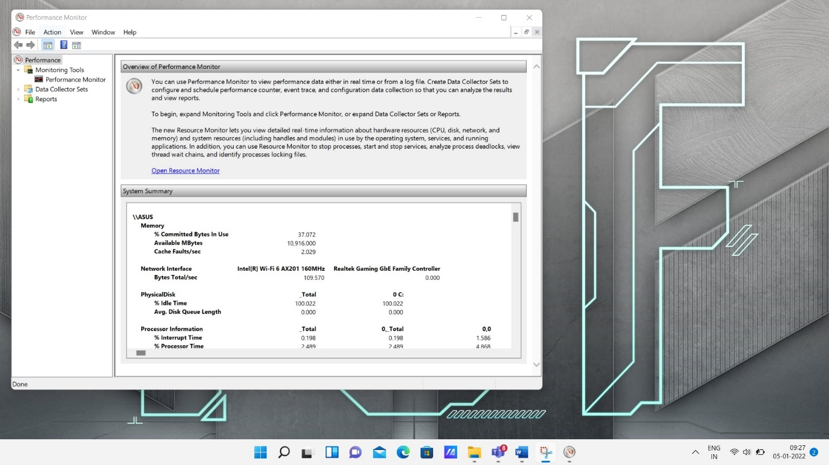

resmon.exe - displays information about the use of hardware and software resources in real time.

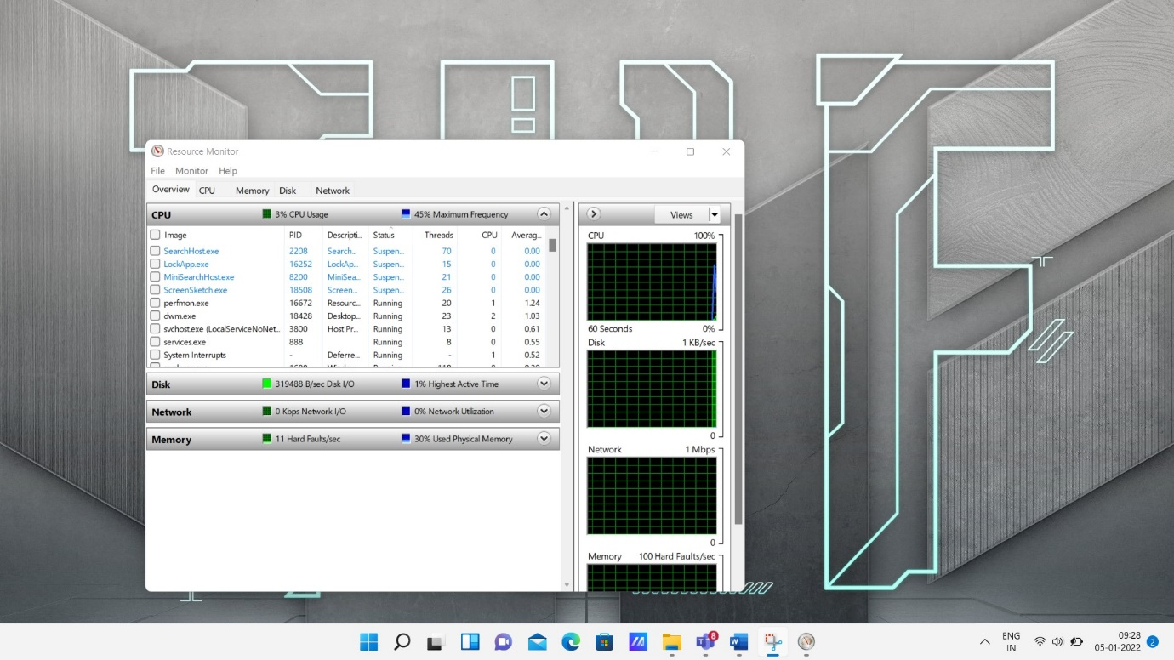

sigverif.exe – Opens file contains machine code.

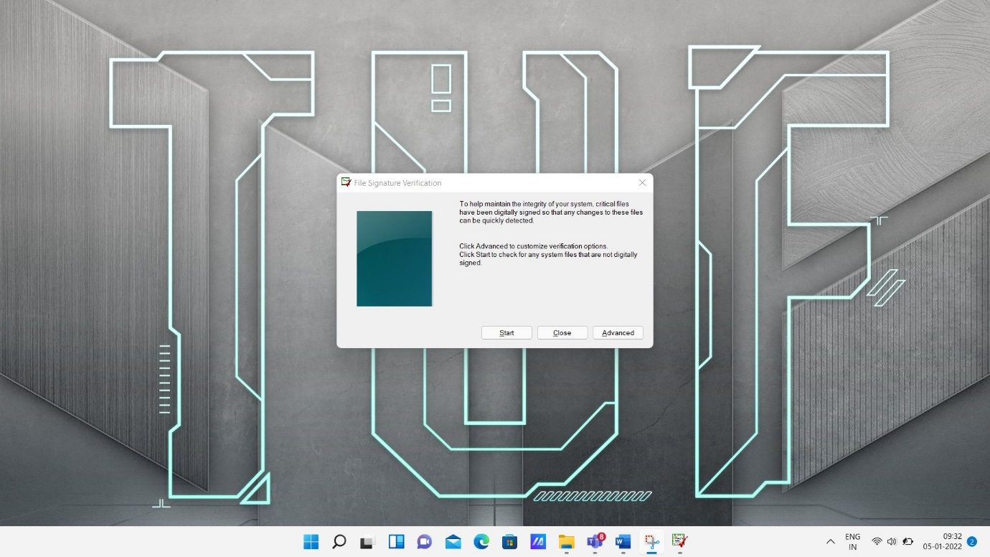

taskmgr.exe - Opens Windows Task Manager

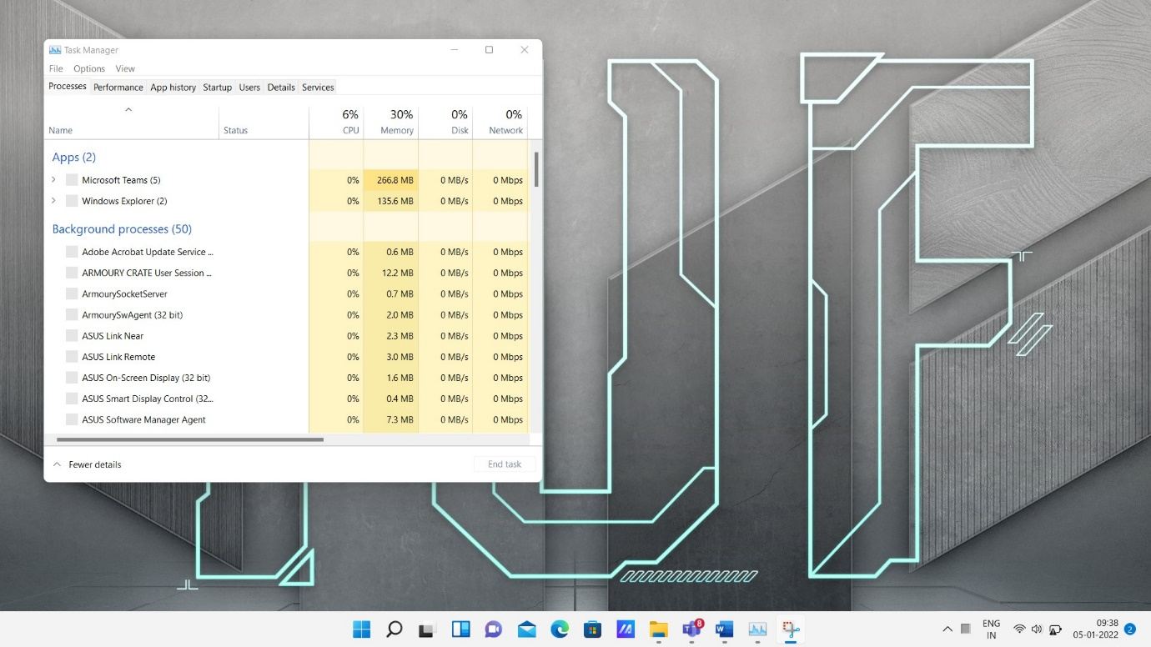

appwiz.cpl - Add/Remove Programs properties

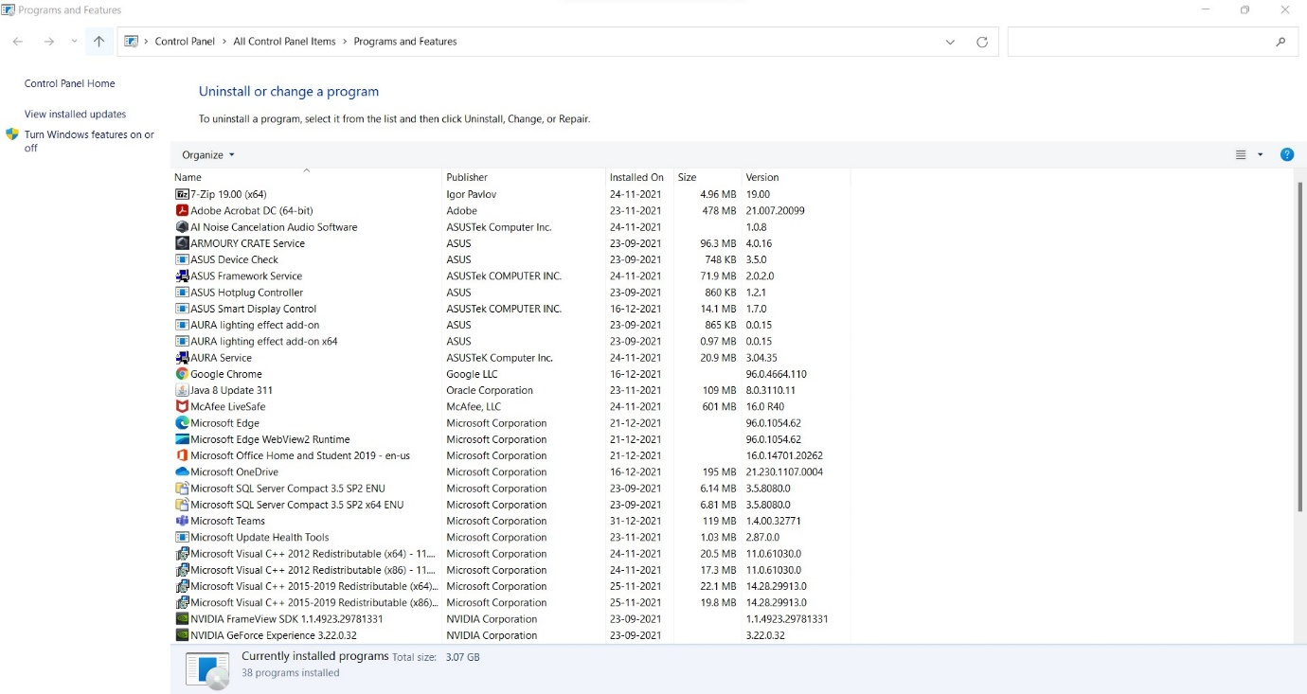

desk.cpl - Display properties

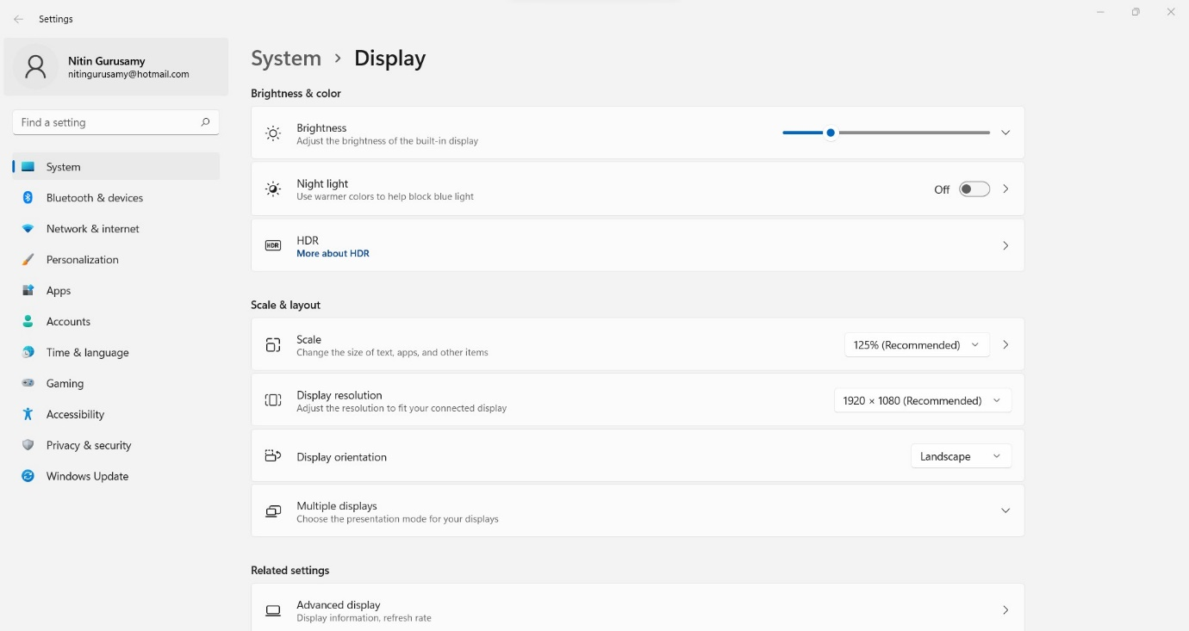

inetcpl.cpl - Internet properties

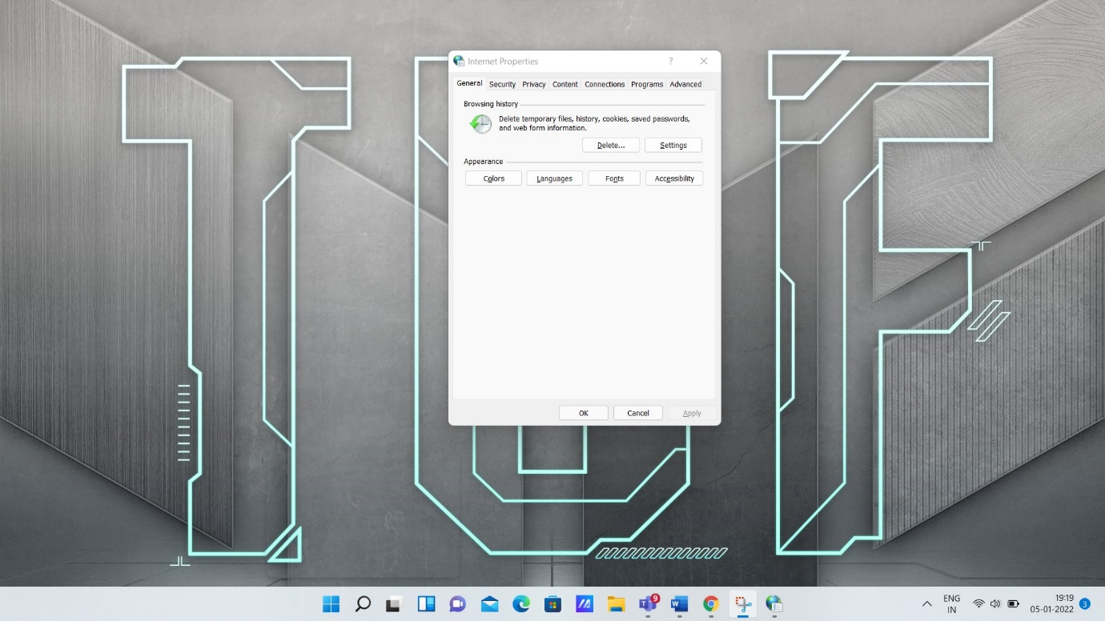

intl.cpl - Regional Settings properties

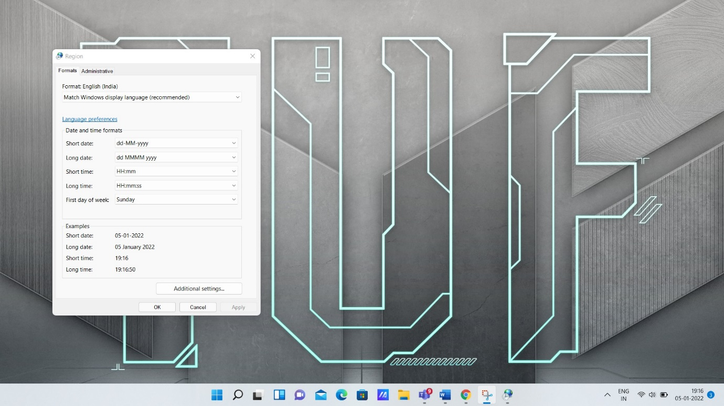

joy.cpl - Joystick properties

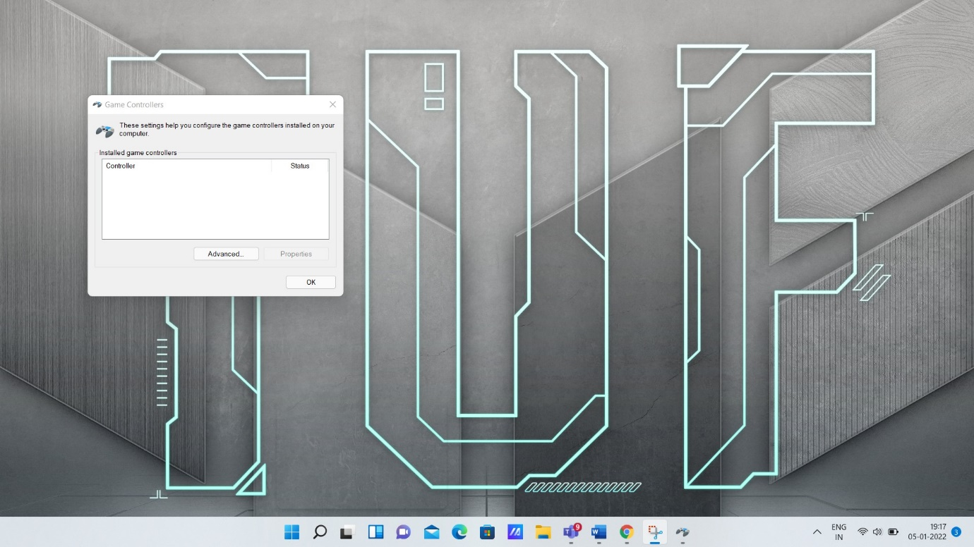

main.cpl - Mouse, Fonts, Keyboard, and Printers properties

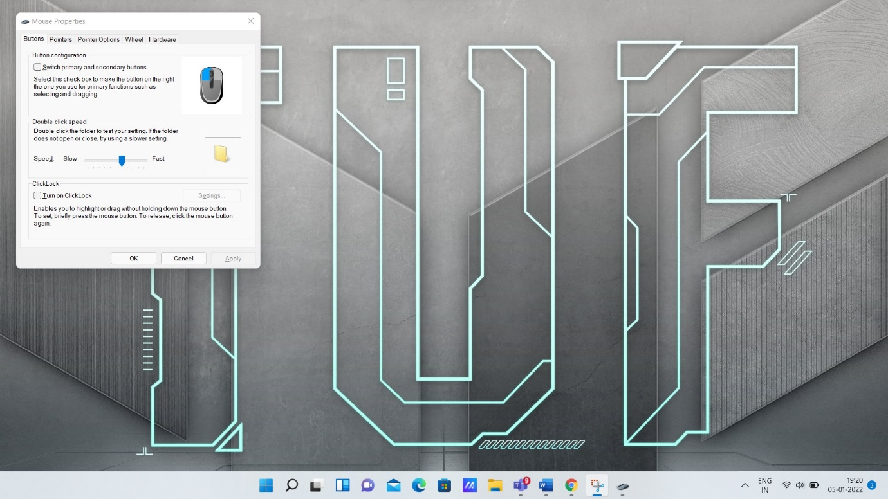

mmsys.cpl - Multimedia properties

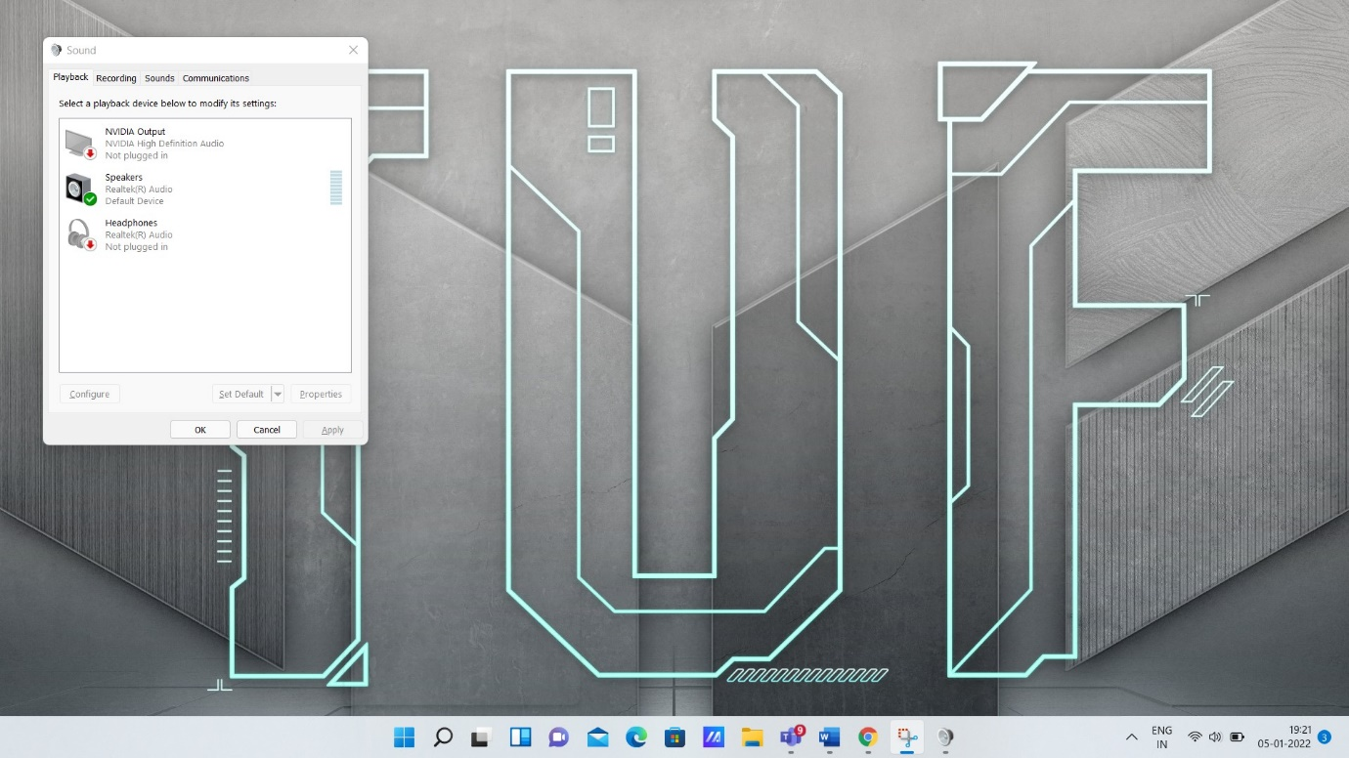

sysdm.cpl - System properties and Add New Hardware wizard

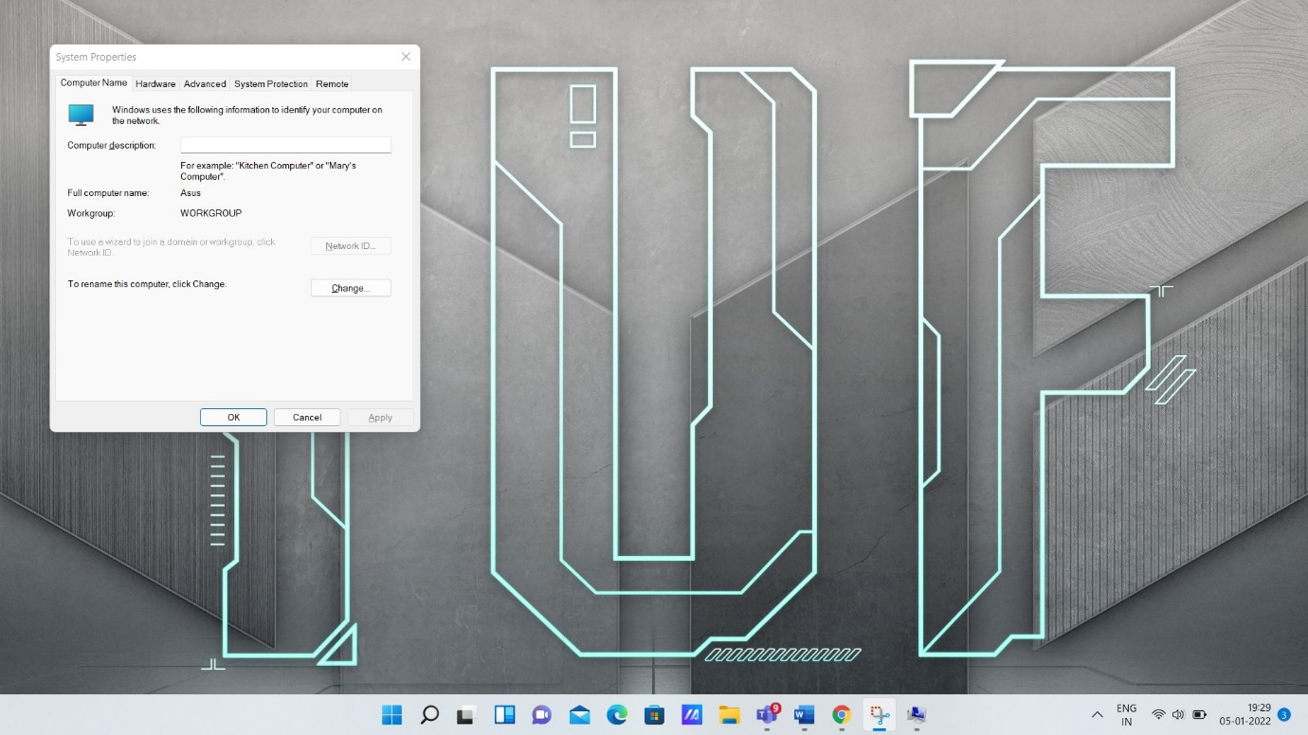

timedate.cpl - Date/Time properties

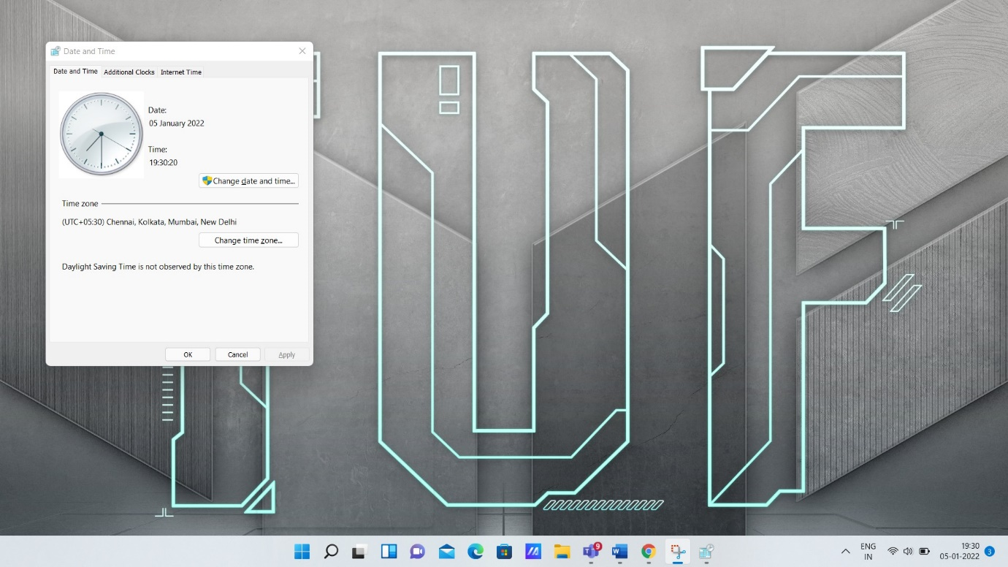

[wscui.cpl](https://www.exefiles.com/en/cpl/wscui-cpl/) - Security and Maintenance file

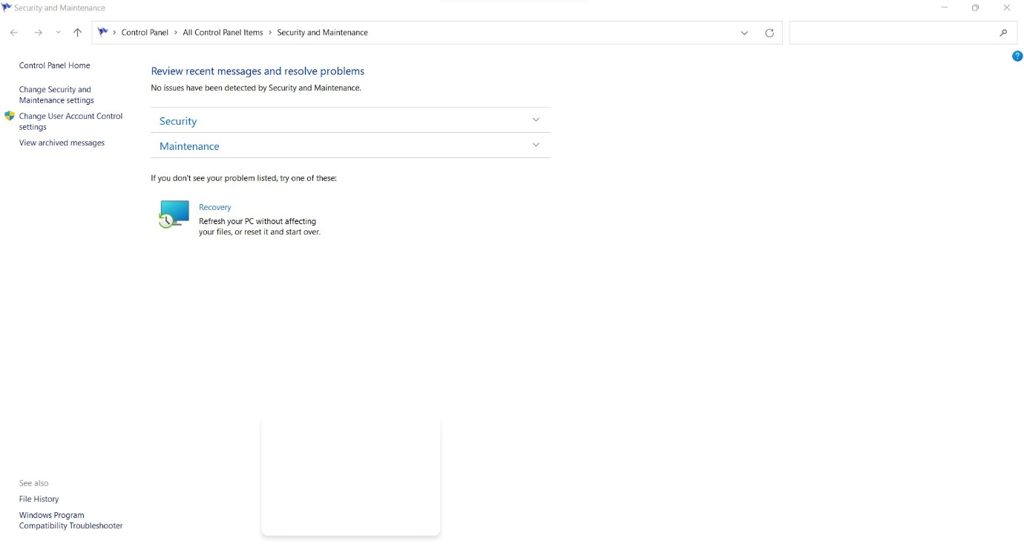

|  |
| --- |
| azman.msc - Manage Authorization Stores    certlm.msc - Loads the list of certificates of the local computer    certmgr.msc - Loads the list of certificates of the user    comexp.msc - Loads Component Services, Event Viewer, and Services    devmgmt.msc - Opens the Device Manager to manage hardware and devices    diskmgmt.msc - Opens Disk Management to administrate connected storage devices    eventvwr.msc - Opens the Event Viewer which displays operating system, software, and  hardware events    fsmgmt.msc - Loads the list of shared folders, sessions, and open files    lusrmgr.msc - Interface to manage local users and user groups |